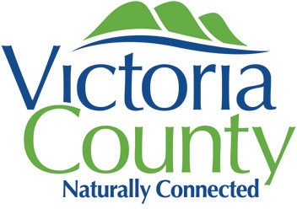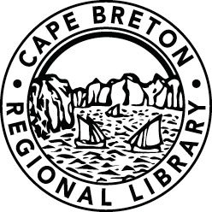
SPONSORED BY
ADMINISTERED IN PARTNERSHIP WITH

HomeWarming Clinic
Are you interested in free energy efficient upgrades for your home? Good news! You could be eligible to receive energy saving upgrades like draft-proofing and insulation – all at no cost to you - through the HomeWarming program.
Want to learn more? Join us at an upcoming HomeWarming Clinic. Meet confidentially with a member of our HomeWarming team and receive one-on-one support to help complete your HomeWarming application on the spot and get answers to any questions you have about the program.
Plus, learn about other helpful programs in your community. This clinic is delivered in partnership with the Municipality of Victoria County and Senior Safety. A representative from each will be on-site to provide information on their services and programs and how they can support you.
Light refreshments and snacks will be provided. Also, just by attending you will be entered into a draw for your chance to win a toaster oven!

Event Details
Wednesday, November 10, 2021, from 1:00 p.m. – 4:00 p.m. Baddeck Public Library, 520 Chebucto Street, Baddeck, Nova Scotia.

RSVP
This is a free event, but you must RSVP in advance to book your meeting time with our HomeWarming team.

To RSVP contact Cora-Lee, Cape Breton Regional Library, at 902-295-2055 or by email baddeck@cbrl.ca.

